

Web Datamining and Semantics

Project





Pierre PETILLION Tom PAYET

Dany PERENCHIO Elie OBADIA

DIA 6

**Pierre PETILLION Tom PAYET**

**Dany PERENCHIO Elie OBADIA**

DIA 6

# Introduction

For this semester, we had to make an application that consisted in integrating all the pieces that have been seen during practical works.

Our application had to include geospatial and dynamic data. We also had to use an ontology to describe entities we had to store.

The objectives were to learn how to interact with RDF files, that gather information from different sources.

We had to choose a subject, in which we could use multiple APIs. We decided to make a website on which customers could see information about train they have booked, like departure and arrival station, departure and arrival hours, and weather in both cities.

# Modelling the ontology

First, we modelled our ontology in Protege in order to gather all the information we needed in one place.

In this ontology, we put all the information needed to include in our database. So we put information about trains, train stations, trips, cities, hours and weather.

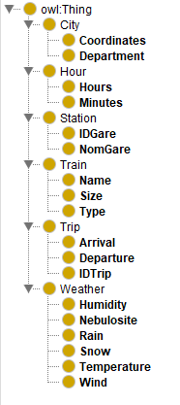

We also created properties to link theses different information, as departure and arrival hour and station, or isStationOf to link each station to a city, and isWeatherOf to link weather to a city.

We selected the appropriate properties and created some individuals to illustrate how to use this ontology.

# Populating the ontology

We used a dataset giving information about stations, including coordinates.

We imported this dataset, and then used the library jsonld to change it into an RDF file. To do this, we also used a JSON-LD file that allowed to convert names of variables into those ones we wanted.

With this method, we obtained a triplestore composed of n-quads syntax.

When it comes to APIs, we decided to use the SNCF and a weather API to show information about the trip and the weather, we coded manually the conversion to RDF file, as it was too complicated otherwise.

# Querying the ontology

As we used JavaScript to connect with our HTML for our website, we used rdfstore to make SAPRQL queries.

These queries are connected to user requests and are triggered automatically when he clicks on the ‘send’ button.

# Manipulating the ontology using Jena

As we are 4 students working on this project, we decided to make a web application to query the data. Moreover, this is more user friendly, as the user knows intuitively how to use our website.

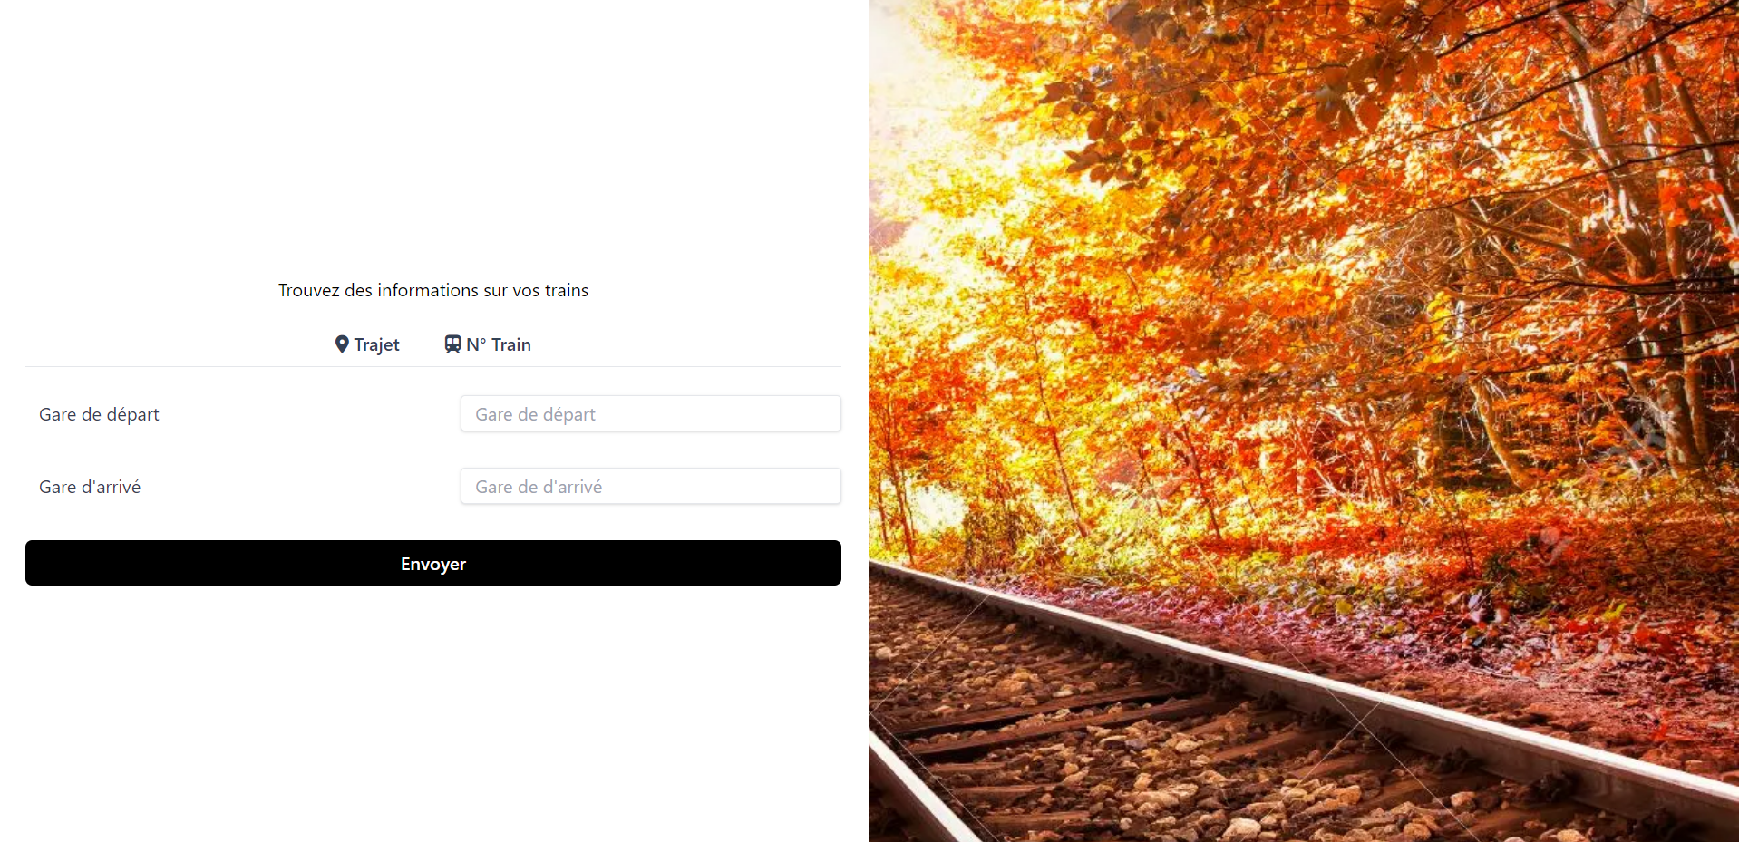

As you can see, the user can choose to put his departure and arrival stations to get information about his trip, or alternatively enter the number of his train.

# Conclusion

This project allowed us to work on a mini website, applying knowledge we acquired in class. We decided to use JavaScript to make the connexion with HTML easier, but using JavaScript made much harder the usage of libraries, especially to deal with RDF conversions, or SPARQL queries.

Unfortunately, as we were short of time, we couldn’t get a perfectly functional website.

However, this project allowed us to improve our skills in web programming, and to deal with OWL format.